Check of ULTC in Dymola pre-and post changes by HT, comparison:

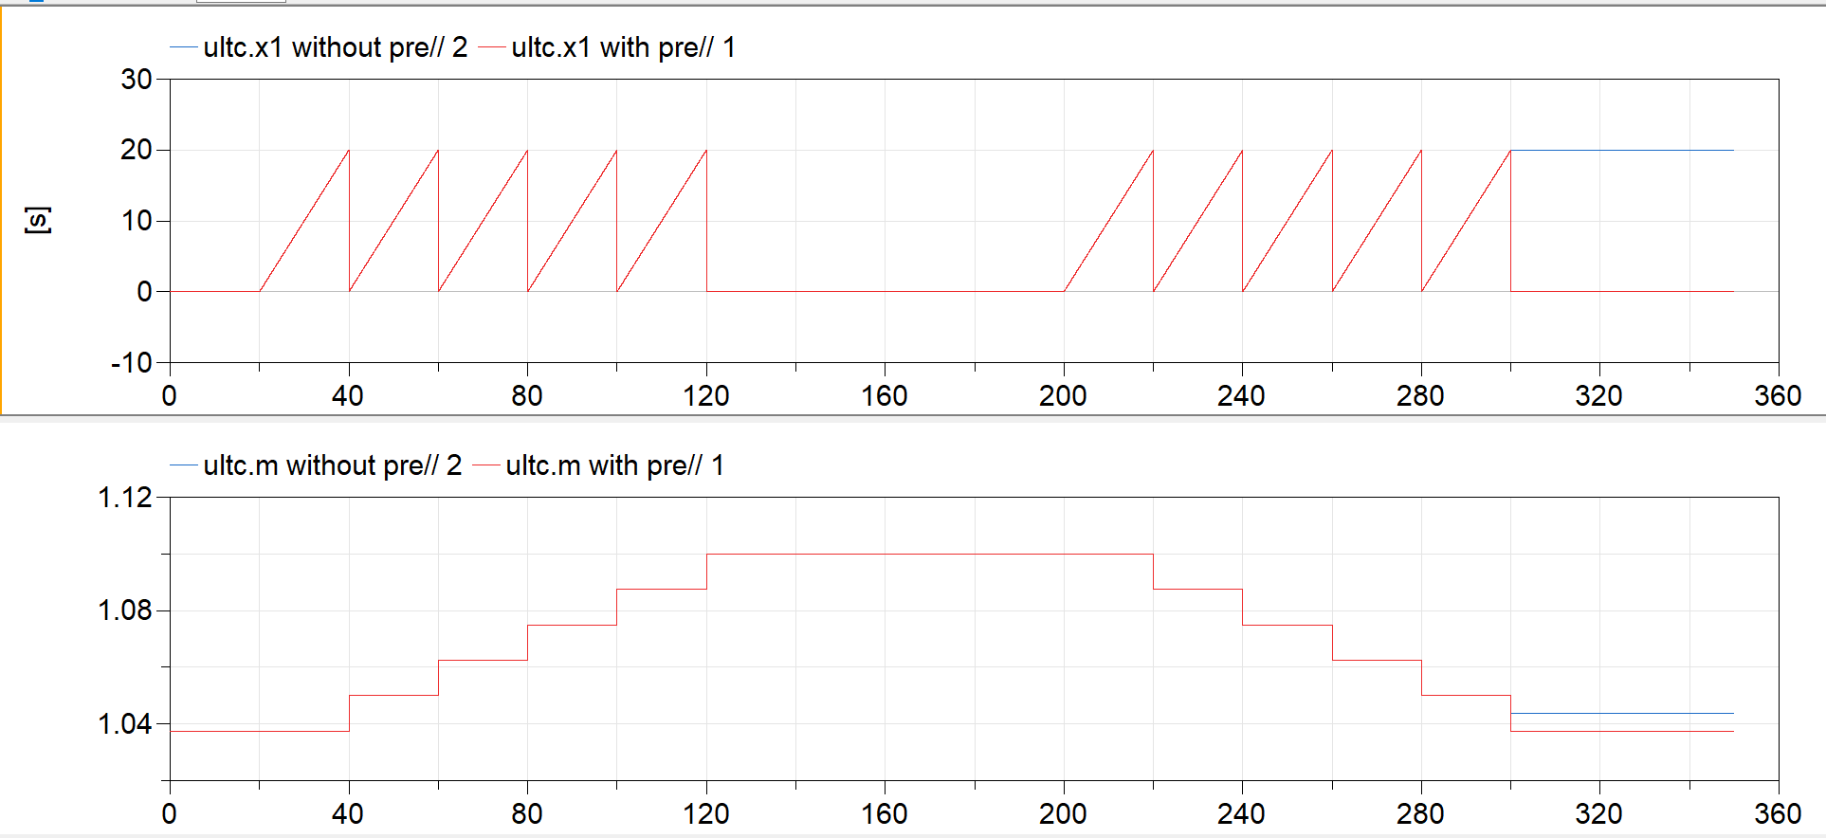

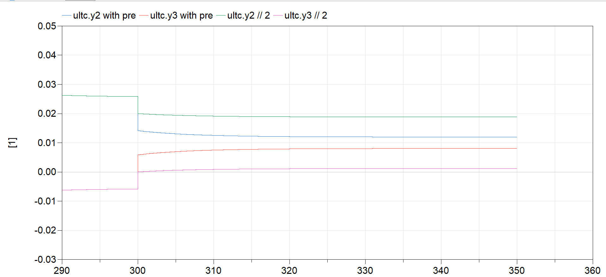

Conclusion: I don’t know how this _should_ look, but it looks “more correct” to me after my changes, i.e. wrapping a pre around y2 < 0 and y3 < 0. Please check!